Lab 5-1 Showing Results with Pivot Tables
Goals | To use the Pivot Table view to display results in Siebel Answers.
Scenario | You use a Pivot Table view to take row, column, and section headings and swap them around to obtain different perspectives of the data. You create multiple drop-down lists for attributes; add totals; override default aggregation rules for measures; display an item’s relative value; use calculations; and modify pivot table formatting.
Time | 20 – 25 minutes
Environment | 
Instructions:
- Create a request and add a Pivot Table view.
  - Create the following request and associated filter:
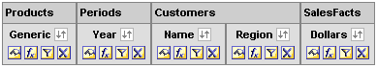
  - Click Results.
  - Click the Pivot Table button at the top of the workspace to add a Pivot Table view. The Pivot Table template is displayed.
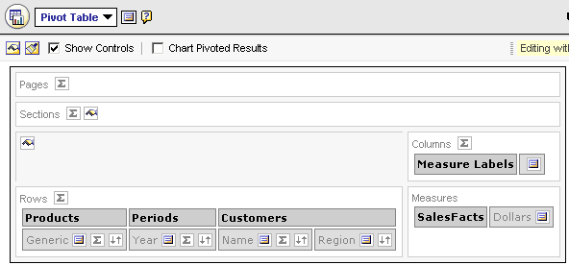
  - Drag Year and Region to the Pages section to create a prompt for the Pivot table.
  - Drag Generic to the Columns section. Make sure Generic is below Measure Labels.
  - Check your work:
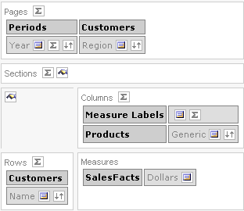
  - Verify that Display Results is checked. If not, check it.
  - Your results should look similar to the following:
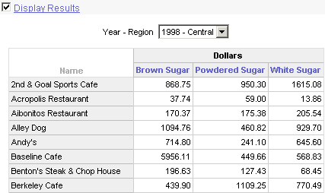
- Create separate drop-down lists for each of the attributes in the Pages layout area.
  - Click the More Options button for Region.
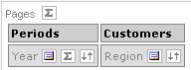
  - Select the option Start New Page Drop Down.
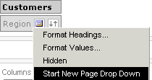
  - Check your results. Notice that there are now two drop-down lists in the pivot table.
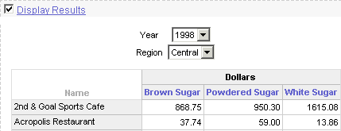
- Add totals to the Pivot table.
  - Click the Totals button in the Columns area and select After.
  - Click the Totals button in the Rows area and select After.
  - Your results should look similar to the following:
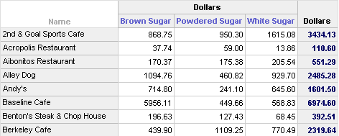
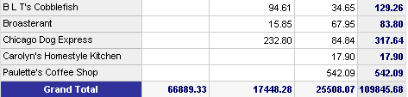
- Override the default aggregation rule for the Dollars measure. The default aggregation rule is specified in the Siebel repository, or by the original author of a report. In this example, the default aggregation rule for Dollars is SUM.
  - What is the total dollar amount for 2nd & Goal Sports Café? You will compare this value with the value after you override the default aggregation rule in the next steps.
  - Click the More Options button for the Dollars measure.
  - Select Aggregation Rule > Average.
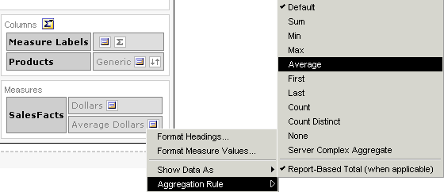
  - What is the total dollar amount now for 2nd & Goal Sports Café?
  - Check your results. Notice that the total dollar amount is now the average rather than the sum.
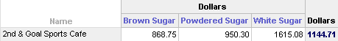
  - Experiment with some of the other available aggregation rules and notice how the value changes for total dollars. When you are done, reset the aggregation rule to Default.
- Add green bar styling and formatting to the Pivot table to make it more visually appealing.
  - Click the Pivot Table View Properties button near the top of the workspace. The Edit View dialog box appears.
  - Click the green bar styling check box.
  - In the alternate drop-down list, select All Columns.
  - If desired, click the Set alternate format button to modify the formatting of the alternating rows.
  - Click OK to close the Edit View dialog box.
  - Check your work. Your results should look similar to the following:
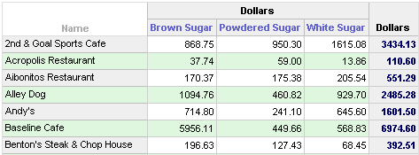
- Add formatting for sections and section content.
  - Drag Region from Pages to Sections. Notice that the Pivot table is now divided into three sections, one for each region.
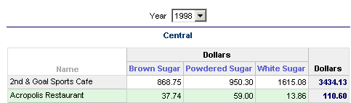
  - Click the Section Properties button.
  - Change the column heading display to Left.
  - Click OK to close the Sections Properties dialog box.
  - Check your work. Your results should look similar to the following:
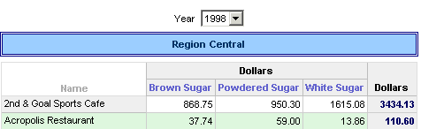
- Show dollars as a percentage of the total for each section.
  - Click the More Options button for Dollars.
  - Select Duplicate Layer.
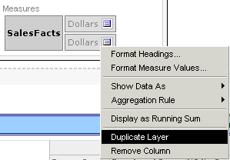
  - Click the More Options button for Dollars again, and select Format Headings. The Edit Format dialog box opens.
  - In the Caption field, type % Dollars.
  - Click OK.
  - Click the More Options button for % Dollars, and select Show Data As > Percent of > Section.
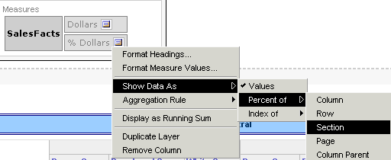
This will display the percentage of the section that this value constitutes.
  - Your results should look similar to the following:
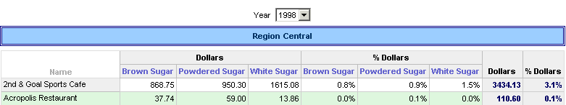
  - Which customer in the Central region bought the highest percentage of sugar in 1998?
  - Which customer in the Central region bought the highest percentage of white sugar in 1999?
- Build a calculation that identifies combined dollar sales and percentages for the East and Central regions only.
  - Click the More Options button for the Region column.
  - Select New Calculated Item. The Calculated Item dialog box opens.
  - In the Name field, type East and Central.
  - In the Function drop-down list, select SUM.
  - On the right, select the Central and East values.
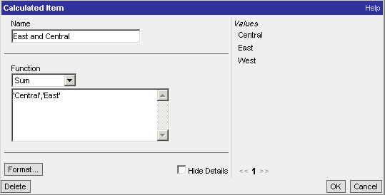
  - Click OK to close the Calculated Item dialog box.
  - Scroll to the bottom of the pivot table. Your results should look similar to the following. Please notice that the screenshot shows only a partial view of the results.
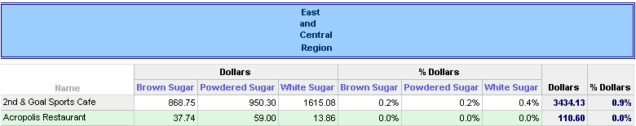
  - Which customer in the East and Central regions purchased the highest percentage of sugar in 1998?
  - Which customer in the East and Central regions purchased the highest percentage of powdered sugar in 1999?
- Build a calculation that identifies combined dollar sales and percentages for powdered sugar and white sugar only.
  - Click the More Options button for the Generic column.
  - Select New Calculated Item. The Calculated Item dialog box opens.
  - In the Name field, type Powdered & White.
  - In the Function drop-down list, select SUM.
  - On the right, select the Powdered Sugar and White Sugar values.
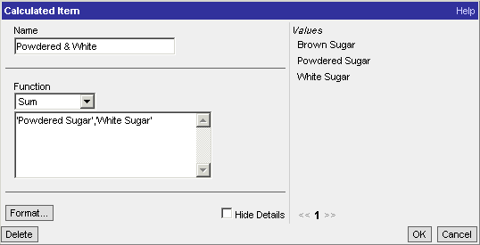
  - Click OK to close the Calculated Item dialog box.
  - Your results should look similar to the following:
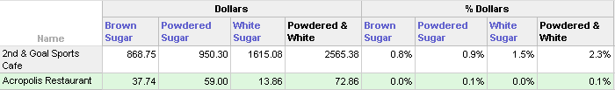
  - Which customer in the Central region purchased the highest percentage of powdered and white sugar in 1998?
- In the Choose a result view drop-down list, select Compound Layout.
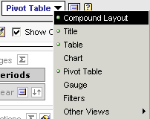
- Delete the Table view in the Compound Layout view. CAUTION: Be sure to delete the Table view, not the Pivot Table view.
- Save the request as My Pivot Table.
- Click the Answers link and verify that My Pivot Table is visible under My Folder.
- Leave Siebel Answers open for the next lab.
Solutions 5-1
Answers
4.a. What is the total dollar amount for 2nd & Goal Sports Café?
$3434.13
4.d. What is the total dollar amount now for 2nd & Goal Sports Café?
$1144.71
7.h. Which customer in the Central region bought the highest percentage of sugar in 1998?
Penn Brewery: 18.7%
7.i. Which customer in the Central region bought the highest percentage of white sugar in 1999?
Demos’ Steak and Spaghetti House: 4.6%
8.h. Which customer in the East and Central regions purchased the highest percentage of sugar in 1998?
Johnny’s: 11.4%
8.i. Which customer in the East and Central regions purchased the highest percentage of powdered sugar in 1999?
Bull Ring: 7.6%
9.h. Which customer in the Central region purchased the highest percentage of powdered and white sugar in 1998?
Demos’ Steak and Spaghetti House: 6.3%
Lab 5-2 Displaying Running Sums in Pivot Tables
Goals | To display running sums in a Pivot table.
Scenario | You display a running sum for dollars from January through December of 1998, and a running sum for percentage of dollars from January through December of 1998.
Time | 5 – 10 minutes
Instructions:
- Create the following request and associated filters:
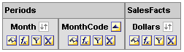
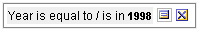
Please note: Delete the Year column from the request after creating the filter.
  - Click the Order By button once to sort the MonthCode column in ascending order.
  - Hide the MonthCode column so it does not appear in the results.
    - Click the Format Column button for the MonthCode column.
    - Click the Column Format tab.
    - Check Hide.
    - Click OK.
- Add a pivot table with totals.
  - Click Results:
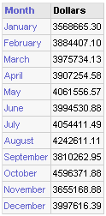
  - In the Choose a result view drop-down list, select Pivot Table.
  - Click the Totals button for Rows.
  - Select After.
  - Check your results:
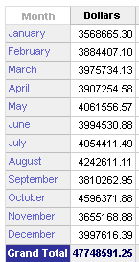
- Build a running sum column for the Dollars measure.
  - Click the More Options button for the Dollars measure.
  - Select Duplicate Layer.
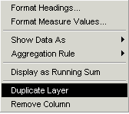
  - Click the More Options button for the duplicate Dollars column you created in the previous step.
  - Select Format Headings.
  - In the Caption field, type RSum Dollars.
  - Click OK.
  - Click the More Options button for RSum Dollars.
  - Select Display as Running Sum.
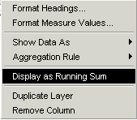
  - Notice that the RSum Dollars column now displays a running sum for dollars from January through December of 1998.
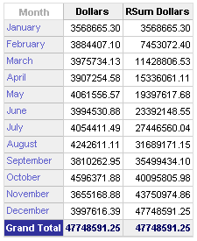
- Build two additional columns to display percentage and running sum for percentage.
  - Click the More Options button for the Dollars measure.
  - Select Duplicate Layer.
  - Click the More Options button for the duplicate Dollars column you just created.
  - Select Format Headings.
  - In the Caption field, type %Dollars.
  - Click OK.
  - Click the More Options button for the %Dollars columns.
  - Select Show Data As > Percent of > Column. The column displays the percentage of total revenue earned in each month.
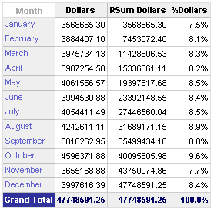
  - Click the More Options button for the %Dollars measure.
  - Select Duplicate Layer.
  - Click the More Options button for the duplicate %Dollars column you just created.
  - Select Format Headings.
  - In the Caption field, type RSum %Dollars.
  - Click OK.
  - Click the More Options button for the RSum %Dollars columns.
  - Select Display as Running Sum. The RSum %Dollars column now displays a running sum for percentages from January through December of 1998.
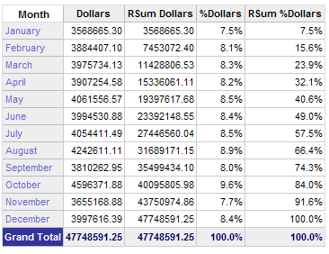
- Save as My Running Sum Table.
- Leave Siebel Answers open for the next lab.

